Automated Support Infrastructure Dashboard Overview
Table of Contents

Introduction 4
ASI Dashboard goals 5
Views 6
Views – A closer look 7
Views – Important note 7
ASI Dashboard information coverage 8
Left pane 11
Left pane navigation 12
Right pane 12
Item and events 12
View 14
Machine group 14
Monitored item group 15
Machine 15
Monitored item 16
Profile 17
Security 17
Resources 18
Events 19
Maintenance 20
Configuring the ASI Dashboard 20
Configurable items 21
Per user 21
Per view 21
Per monitored item group 21
Per monitored item 21
Per machine group 21
Per profile item 21
Per security item 22
Per resource item 22
Per event item 22
Per maintenance item 22
Configuration wizards 22
Status 23
Appendix A – Asset Profile Sample Excerpt 24
Appendix B – ASI Dashboard Default Configuration 25
Default ASI Dashboard configuration 25
Dashboard left pane configuration 25
Notes 25
Default items 25
Event monitoring and update intervals 26
Status values 26
Event monitoring and update intervals 27
Default values 27
Monitored item groups 27
Clients 27
Services 28
Profile items 32
Security items 32
Intrusion protection exclusion lists 33
Resource items 39
Event items 41
Maintenance items 46

Introduction
The ASI Dashboard is the default ASI server interface. It is displayed when you log onto your ASI server at
https://asiservername/main
You can still access the individual ASI facilities, events, assets, sites, microsoft updates, provisioning, information portal, and tools, by clicking on the Use extended interface link found on the right-hand side of the ASI Site and System Dashboard page above the ASI Dashboard:
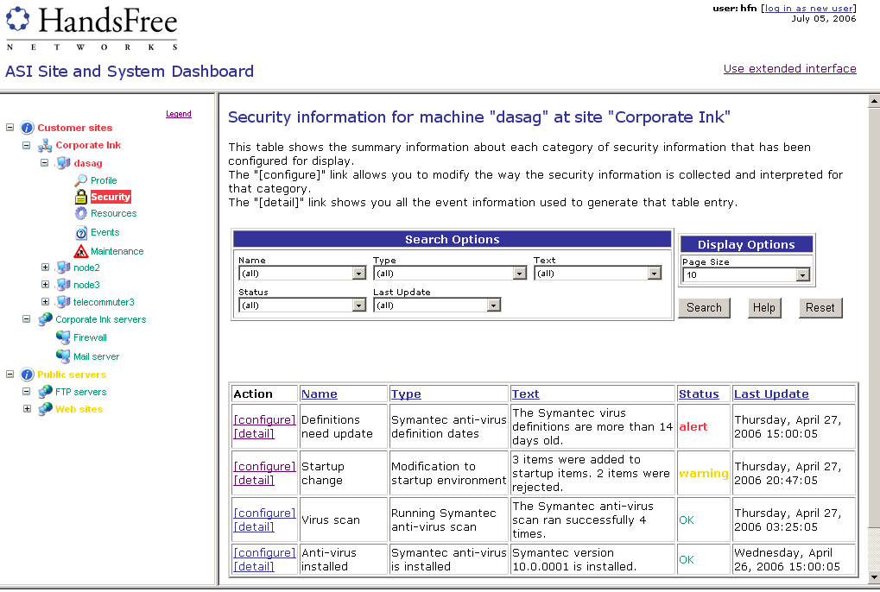

The ASI Dashboard has a two-pane structure.
In the left pane, you navigate all system based objects, sites, machine groups, and monitored item groups, via a familiar tree structure expanding and contracting system groupings by clicking on +, and – icons respectively.
Entries in the left pane at all levels are color-coded to reflect their current status, green – normal, yellow – warning, and red – alert.
Note that the ASI Dashboard includes monitored item groups. These are groups of objects such as devices, MS Windows services and applications that you want to monitor. The default ASI Dashboard configuration includes the Services and Clients monitored item groups. The former includes monitoring of MS Windows services on all systems where the ASI client is installed. The latter includes monitoring of all the ASI clients installed at your sites.
In the right pane, you can
- View a system’s asset, security, maintenance, resource, and events-of-interest item groups
- View monitored item status
- Take action on detail entries in a system’s security, maintenance, resource, and events-of-interest profiles
- Configure the left pane including which groups should be included, and how they should be grouped together
- Configure a system’s status snapshot including its asset, security, maintenance, resource, and events-of-interest profiles
- Configure status display parameters controlling the thresholds that define normal, warning, and alert status
- Define and configure monitored item groups
All right-pane displays have the same structure. The title of a display contains the name of the item you clicked on followed by Search Options, and a Display Options panels. Below the two panels, typically you will find a table containing top-level detail items with actions available for each item in the table.

ASI Dashboard goals
The ASI Dashboard is designed to be easily and quickly tailored to the preferences of individual users, and requiring a minimum effort to configure. For this to be true:
- The ASI Dashboard display should persist: it should be the same after the browser is closed and re-opened.
- The ASI Dashboard display should be per-user: Different ASI server users should be able to have different persistent dashboard displays.
- The ASI Dashboard display should bring together different kinds of data into a uniform framework.
- Within one ASI Dashboard display, a user should be able to define multiple views based on any criteria, showing selections of systems that may be overlapping, i.e. the same systems may be included in multiple views. The ASI Dashboard should lend itself to easily drilling down to help diagnose problems.
- The ASI Dashboard display should update quickly, even at the expense of the data being slightly out of date.
Please note two ASI architectural characteristics that affect the ASI Dashboard:
- The information displayed on the ASI Dashboard is collected via the ASI client which can only have a single configuration on any given system, i.e. it cannot have multiple configurations matching the user oriented dashboard configurations.
- Systems can be in more than one machine group. This means that, for example, if a system belongs to two or more groups with different configurations we need a way to resolve potential conflicts

Views
One of the key concepts in the ASI Dashboard is that of the view. It makes it possible to achieve the goals outlined in the ASI Dashboard goals of this document. The best way to explain what we mean by view is by way of an example.
Suppose you offer your customers three service levels:
- Premium
- Standard
- Basic
Each service level is defined in terms of the services provided, and the level of each service is specified in terms of parameters such as response time to problems, types of problems covered, and their thresholds.
In this example, the views mechanism would let you configure the ASI Dashboard to support the delivery of services to your customers based on the level of service you have contracted to provide them.
Given the three service levels defined above, you would define three views calling them,, for example:
- Premium
- Standard
- Basic
To each of the views, you would add the sites, system groups and monitored item groups including the systems covered by the corresponding service levels.
For each view you could assign different threshold values for normal, warning, and alert status for each of the components of a system’s status. You could also define different events-of-interest profiles, and different monitoring intervals.

Views – A closer look
Users can define and configure the views shown on their ASI Dashboard display. Each view consists of a list of machine groups and a list of monitored item groups. You can expand a view to see what is in it, and can expand items belonging to them to see their content.
Users can define the views they want to see on their ASI Dashboard display. Each user on an ASI server can have a tailored ASI Dashboard display.
Each view in an ASI Dashboard display is configured independently both in terms of the groups of systems included, and other parameters such as status threshold.
Views can be global so that others can use them, or they can be private. Global views can only be edited by their owner (the user that created them).

Views – Important note
Scrip configurations are applied on a system-by-system basis. With group management Scrip configurations can be assigned to groups of systems defined according to any criteria. Systems can belong to multiple groups. However, at any one point in time, for any Scrip configuration variable only one value can be assigned to one system.
ASI Dashboard displays are composed of views, and are defined per user. However, information that populates the ASI Dashboard’s right pane, and actions performed by clicking on links in the right pane are generated and performed via Scrip configurations.
Scrip configurations apply to groups of systems with only one Scrip configuration assigned to any one system at any point in time regardless of the user. Scrip configurations are user independent.
This means that the items that are included for display in a machine group are per machine group, not per view or per user. In other words, when multiple users select a machine group for a view, they all see the same information when they expand the entry for the machine group in the left pane, and also when they expand the left-pane entry for a machine within the machine group. Similarly, if a single user selects a machine group in two different views, those two views show the same information when that machine group is expanded. This is because:
- The contents of the machine group are independent of the user, so each user sees the same machines when expanding it, and
- The Scrip configuration for collecting the data that is presented has to be set up one way on a single machine, so different users can't have different configurations for it.
The best way to illustrate the constraints placed on views because Scrip configurations are per machine not per view is by way of an example. Suppose you have two machines groups, web and email with system webmail in common.
You configure web to have a resource item for network traffic, with a certain threshold (and this configures an underlying Scrip in all systems in that machine group). You configure email to have a resource item for disk space with a certain threshold (and this configures the underlying Scrip in all systems in that machine group).
Suppose you configure one view to contain the machine group web and another view to contain the machine group email. This means that webmail, the machine the two groups have in common, is in both views. However, when you look at the top-level resource items for webmail (and any other system), with the status rolled up from the detail resource items, that list of resource items is per-machine, NOT per-view. So, the resource items will be exactly the same in both views. If, for example, the network resource has an alert status, it will still cause both views at the top level to be at alert status.
The underlying assumption is that the main use of views is to aggregate groups of machines based on user defined criteria.
It’s also possible to inadvertently configure the same function (Scrip) on the same system in conflicting ways. For example, suppose you have two monitored item groups that define two different machine groups, A and B, to do the monitoring, with two different schedules.
Suppose also that machine groups A and B have one system, X, in common.
It’s easy to resolve the conflict caused by the fact that system X is required to monitor different systems by simply combining the two lists of systems to be monitored in the Scrip configuration for system X.
However, we cannot as easily resolve the scheduling conflict. We resolve it by selecting the schedule attached to the machine group belonging to the group category with the higher priority. If the two machine groups with conflicting Scrip configurations, in our example A and B, belong to the same category, we use the Scrip configuration value from the machine group that was created more recently.
In summary, you can use the wizards to configure data-collection settings on groups of machines. Behind the scenes, the ASI server converts this into Scrip settings on individual machines, resolving any conflicts. Then, you can use the wizards to set up which groups you would like to see in your view. When you look at your view, you see those groups, and you can expand the left-pane entry for each one to explore the data that has been collected for each machine.

ASI Dashboard information coverage
The ASI Dashboard lets you manage and access information about the systems you have under management in an intuitive and straightforward manner. With the ASI Dashboard you can:
- Access all the information about systems under management via one interface
- Customize which and how much information you view
- Configure the views and the Scrips used to collect information and take action reported on the ASI Dashboard. ASI Dashboard configuration is wizard based making the configuration process more intuitive and straightforward.
System related information covered by the ASI Dashboard is sub-divided into five Item Categories:
- Profile
- Security
- Resources
- Events of interest
- Maintenance
In addition to the above system related item categories, there is also the Monitoring item category that includes information about ASI client activity monitoring the availability of the ASI client, MS Windows services, devices, and applications.
For each item category, you can configure the ASI Dashboard to display the following information:
- System profile summary: This is asset information that is collected by the System Survey (Scrip 61). You can select the hardware and software asset data you want included in the Profile item category.
- Security: This is security related information included in the Security item category. It is extracted from the asset database, and from the information reported by the following Scrips:
- Symantec Virus Definition Management (Scrip 12)
- McAfee Virus Definition Management (Scrip 90)
- eTrust Virus Definition Management (Scrip 242)
- Trend Micro Virus Definition Management (Scrip 247)
- Norton Anti Virus Scan Execution (Scrip 15)
- McAfee VirusScan Execution (Scrip 175)
- eTrust EZ Antivirus Scan Execution (Scrip 243)
- Trend Micro Anti Virus Scan Execution (Scrip 249)
- Symantec Anti Virus Definition Dates Log (Scrip 238)
- McAfee Anti Virus Definition Dates Log (Scrip 239)
- eTrust EZ Antivirus Definition Dates Log (Scrip 244)
- Trend Micro Anti Virus Definition Dates Log (Scrip 250)
- System Start-up Environment Control (Scrip 27)
- Intrusion Protection Control (Scrip 232)
- System Start-up Environment Management (Scrip 233)
- Intrusion Protection Management (Scrip 240)
In a later version, we will include event information from:
- Network Packet Filtering (Scrip 228)
- Port Probe Detected (Scrip 45)
- Email Attachment Filtering (Scrip 188)
- File Download Filtering (Scrip 189)
- Device, service, and application availability: This is information about systems and services that are monitored for uptime and availability. It is used to generate the display for the Monitored item item category. The device, service, and application availability information is collected using:
- Network Devices and Services Availability (Scrip 88). This Scrip directly pings or opens a connection to an IP resource or service, and reports on the success or failure of that operation.
- ASI client Heartbeat (Scrip 231). This Scrip posts an event log on the ASI server at regular intervals, making it possible to directly monitor the availability of the ASI clients and the systems they run on.
- File Distribution and Retrieval (Scrip 100). This Scrip is similar to the Network Devices and Services Availability Scrip (#88) except that it goes further and retrieves a file from the resource, verifying that it is properly serving files. Typically, it is used to monitor the availability of Web based applications.
- Service Restart (Scrip 176). This Scrip verifies that MS Windows services are running on a system, and posts an event log if they are not. It can be configured to re-start monitored MS Windows services when they stop.
- Resource utilization: This is performance related information about a system. It represents an early-warning system about potential performance related problems. This information is used to generate the display for the Resource item category. In future, we will be adding the capability to the ASI client to report any performance information that is available in the NT performance counters, but for now, resource utilization information reported on the ASI Dashboard is collected via the following Scrips:
- Memory Statistics (Scrip 6)
- Logical Disk Statistics (Scrip 95)
- Processor Statistics (Scrip 96)
- Physical Disk Statistics (Scrip 97)
- Network Statistics (Scrip 98)
- Events of interest. This is event information reported by the ASI client. You can think of the events of interest display as the notification console for a system. Note that it is completely independent from the event notification console accessible via the extended interface. You can use any event filter to select events of interest on a system-by-system basis. The events-of-interest configuration wizard provides assistance in categorizing the filters.
- Maintenance. This is information reported by the maintenance related Scrips. The maintenance display is like the events-of-interest display the only difference being the events it covers. Using the corresponding wizard, you can configure the Maintenance item category for a system to display events from one ore more of the following Scrips:
- Scandisk Execution (Scrip 9)
- Clean Folders (Scrips 60, 217-221)
- Scandisk Files Clean-up (MS Windows 9x and Me) (Scrip 62)
- Chkdsk Files Clean-up (MS Windows NT4, 2000, XP, and Server 2003) (Scrip 69)
- Synchronization of System Clock with Time Server (Scrip 86)
- Difference between System and Time Server Clock Exceeds Configured Threshold Since Last Checked Twelve Hours Ago (Scrip 87)
- Disk Defragmenter Execution (MS Windows 9x and Me) (Scrip 19)
- Disk Defragmenter Execution (MS Windows NT4 and 2000) (Scrip 92)
- Disk Defragmenter Execution (MS Windows XP and Server 2003) (Scrip 211)

Left pane
Items in left pane of the ASI Dashboard are organized according to the following hierarchy:
- View
- Group
Machine group
Monitored item group
- Item
Machine
- Detail category (only for machines)
Profile
Security
Resources
Events
Maintenance
Monitored item

Left pane navigation
Each item in the left pane hierarchy has a + or - next to it, for opening or closing it. When you open it by clicking on the + next to it, the items belonging to it are displayed in a tree structure below it.
Each item in the left pane is color-coded using the rolled-up status for the color selection. This means that an item will have a status equal to the highest status of one of the items belonging to it. For example, if a system group has three systems one with status normal (green), one with status warning (yellow), and one with status alert (red), the group’s status will be displayed as alert (red).
Selecting an item in the left pane highlights it, and updates the display in the right pane, which is always a page with Search Options and Display Options panles listing the details for the selected item.
When nothing in the left pane is expanded, the right pane will just show the color-coded list of views available in the left pane. When a view is expanded by clicking on the + next to it, all the groups (both machine groups and monitored item groups) it contains are shown indented underneath it, and all other views continue to be shown. Similarly, when a group is expanded by clicking on the + next to it, all the items it contains are shown indented underneath it. When you click on the + next to a machine, the following five item categories will always be listed indented under it:
- Profile
- Security
- Resources
- Events
- Maintenance
Monitored items cannot be expanded because only the monitoring function is applied to them.

Right pane
In the right pane of the ASI Dashboard, there are a number of possible different displays corresponding to the item you clicked on in the left pane.

Item and events
As described in the ASI Dashboard information coverage section of this document, information managed via the ASI Dashboard is sub-divided into six item categories:
- System related
- Profile
- Security
- Resources
- Events of interest
- Maintenance
- Monitoring
Each item category is composed of item types. Each item type consists of:
- A Scrip
- Event filtering,
- Scope (the portion of the Scrip’s event log the event filtering is applied to), and
- Parameter extraction operation. This is the action performed to extract the information that is compared to the status threshold values, and determines the status of the item type.
When the ASI Dashboard is updated, the ASI Dashboard software processes all enabled item types. It retrieves the event logs for the Scrips in the enabled item types applying each item type’s event filter to its scope. Parameter extraction is then performed, and the resulting value is compared to the status thresholds for the item type resulting in the updated status for the item type.
The ASI Dashboard retains the event logs retrieved when it processes an item type for a period of time equal to the monitoring interval for that item type.
As described in the Left pane navigation section of this document, you can access item category information for any system by expanding the left-pane entry for a system (clicking on the + to the left of the system name), and then clicking on the desired item category (e.g. Security).
When you do that, the page displayed in the right pane contains a table whose entries are the enabled item types for that item category.
If you click on the detail link for an item type entry in a system’s item category table in the right pane, a page listing all of the event logs retrieved when the ASI Dashboard software processes that item type is displayed in a new window.
Please note that the item count for an item type could be higher than the number of event logss reported for that item type For example, a single Scrip 27 (System Start-up Environment Control) could report the rejection of the attempted addition of six start-up items. In this case the item count for the Scrip 27 item type change to startup environment was prevented will be six while the event count will be one.

View
When you click on the name of a view in the left pane, the display in the right pane contains a title including the name of the view whose entry you clicked on in the left pane, the usual Search Options and Display Options panels, and a table listing the groups (machine groups and monitored item groups) contained in the view. The rows are color-coded corresponding to the status as defined in the configuration of the view. Each entry (row) in the table contains the following columns:
- Actions links
- Configure: Clicking on this link takes you to the step in the dashboard configuration wizard, where the machine group has been pre-selected.
- Manage. Clicking on this link takes you to the Group Scrip configurator page for the machine group. Note that there is no manage link for monitored item groups as they include systems that may not have the ASI client installed.
- Name
- Type ("machine" or "monitor")
- Status
- Number of items
- Last update. This is the latest date and time on which information about the machine or monitored item group changed. There are two last update entries one reporting when the last update was recorded on the ASI client, and one when it was posted on the ASI server.

Machine group
When you click on the name of a machine group in the left pane, the display in the right pane contains a title including the name of the machine group whose entry you clicked on in the left pane, the usual Search Options and Display Options panels, and a table listing the systems contained in the machine group. The rows are color-coded corresponding to the status as defined in the configuration of the view the machine group is listed in. Each entry (row) in the table contains the following columns:
- Actions links
- Configure. Clicking on this link takes you to the step in the dashboard configuration wizard, where the machine has been pre-selected.
- Manage. Clicking on this link takes you to the Scrip configurator page for this machine.
- Event. Clicking on this link takes you to the ad-hoc query page selecting recent events for this machine.
- Asset. Clicking on this link takes you to the asset detail page for this machine.
- Site name
- Machine name
- Status
- Latest Client Event. This is the latest date and time on which information about the machine changed. There are two last update entries one reporting when the last update was recorded on the ASI client, and one when it was posted on the ASI server.

Monitored item group
When you click on the name of a monitored item group in the left pane, the display in the right pane contains a title including the name of the monitored item group whose entry you clicked on in the left pane, the usual Search Options and Display Options panels, and a table listing the monitored resources contained in the monitored items group. The rows are color-coded corresponding to the status as defined in the configuration of the view the monitored item group belongs to. Each entry (row) in the table contains the following columns:
- Actions links
- Configure. Clicking on this link takes you to the step in the dashboard configuration wizard, where the monitored item group has been pre-selected.
- Name
- Location. This is the location of the resource being monitored. This can be a NetBIOS name, IP address, domain name, or URL, depending on how it is used by the client.
- Type. This is the type of monitoring employed to monitor the resource, e.g. Ping, testing for the availability of TCP services, ASI client heartbeat, fetching a file with FTP, or fetching a file with HTTP
- Monitoring machine count
- Status
- Latest Client Event. This is the latest date and time on which monitoring information about the monitored item group changed. There are two last update entries one reporting when the last update was recorded on the ASI client, and one when it was posted on the ASI server.

Machine
When you click on the name of a machine in the left pane, the display in the right pane contains a title including the name of the machine whose entry you clicked on in the left pane, the usual Search Options and Display Options panels, and a table listing the categories of detail information (item categories) for the system whose left-pane entry you clicked on. There are five rows with the categories Profile, Security, Resources, Events, and Maintenance. The rows are color-coded corresponding to the status as defined in the configuration of the view the machine is listed in. Each entry (row) in the table contains the following columns:
- Actions links
- Configure. Clicking on this link takes you to the step in the dashboard configuration wizard, for the item (for example, the wizard for a security item), where the machine has been pre-selected.
- Category
- Status
- Latest Client Event. This is the latest date and time on which information about the machine changed. There are two last update entries one reporting when the last update was recorded on the ASI client, and one when it was posted on the ASI server.

Monitored item
When you click on the name of a monitored item in the left pane, the display in the right pane contains a title including the name of the monitored item whose entry you clicked on in the left pane, the usual Search Options and Display Options panels, and a table listing the systems used to monitor the monitored item whose left-pane entry you clicked on.
Please note that a monitored item does not have to be a device where the ASI client is installed. It could be any device with a name and IP address reachable by devices where the ASI client is installed.
The rows in a monitored item table are color-coded corresponding to the status as defined in the configuration of the view the monitored item is listed in. Each entry (row) in the table contains the following columns:
- Actions links
- Configure. Clicking on this link takes you to the step in the dashboard configuration wizard for monitored items, where the machine used to monitor the selected monitored item has been pre-selected.
- Detail. Clicking on this link generates a new page listing the monitoring events that provide the monitoring information about the selected monitored item generated by the ASI client on the monitoring system whose detail link you clicked on. On the new page, each event has a detail link that takes you to the event detail page for the event.
- Site name
- Machine name
- Status
- Latest Client Event. This is the latest date and time on which the monitoring information about the selected monitored item changed. There are two last update entries one reporting when the last update was recorded on the ASI client, and one when it was posted on the ASI server.

Profile
When you click on the profile entry for a machine in the left pane, the display in the right pane contains a title including the name of the machine whose profile entry you clicked on in the left pane, the usual Search Options and Display Options panels, and a table listing the asset items you selected for the profile of systems belonging to the group you accessed in the left pane
The format of the profile display is as shown in this excerpt of a sample profile page in Appendix A..
The profile display has a single “last update" date on it. It is the latest date and time on which asset information about the selected system changed.

Security
When you click on the security entry for a machine in the left pane, the display in the right pane contains a title including the name of the site and of the machine whose entry you clicked on in the left pane, the usual Search Options and Display Options panels, and a table listing the security categories of detail information configured for the system whose left-pane security entry you clicked on. The entries in the table are color-coded corresponding to the status as defined in the configuration of the view the system is listed in. Each entry (row) in the table contains the following columns:
- Actions links
- Configure. Clicking on this link takes you to the step in the dashboard configuration wizard for security items, where the security item has been pre-selected.
- Detail. Clicking on this link generates a new page listing the security related events for the selected security item generated by the ASI client on the system whose security link you clicked on. On the new page, each event has a detail link that takes you to the event detail page for the event.
- Name. Name of entry corresponding to an item type in the Security item category
- Status
- Item Count. This is the number of occurrences of the item type whose name is entered in the Name column. Please note that the item count for an item type could be higher than the number of events reported for that item type as reported when you click on the Detail link for the entry. For example, a single Scrip 27 (System Start-up Environment Control) could report the rejection of the attempted addition of six start-up items. In this case the item count for the Scrip 27 item type change to startup environment was prevented will be six while the event count will be one.
- Criterion. This is the test applied to the event count reported for the item category type in the entry that results in the status displayed in the Status column. For example, an alert status will result if the number of disabled start-up items additions exceeds 100. For item category entries corresponding to other item types, no test is applied to the number of events reported, e.g. Anti-virus is installed. In these cases, the Criterion column is empty.
- Latest Client Event. This is the latest date and time on which the selected security related item information about the system changed. There are two last update entries one reporting when the last update was recorded on the ASI client, and one when it was posted on the ASI server.

Resources
When you click on the resources entry for a machine in the left pane, the display in the right pane contains a title including the name of the site and of the machine whose entry you clicked on in the left pane, the usual Search Options and Display Options panels, and a table listing the resource items configured for the system whose left-pane resources entry you clicked on. The entries in the table are color-coded corresponding to the status as defined in the configuration of the view the system is listed in. Each entry (row) in the table contains the following columns:
- Actions links
- Configure. Clicking on this link takes you to the step in the dashboard configuration wizard for resource items, where the resource item has been pre-selected.
- Detail. Clicking on this link generates a new page listing the resource monitoring related events for the selected resource item generated by the ASI client on the system whose resource link you clicked on. On the new page, each event has a detail link that takes you to the event detail page for the event.
- Name. Name of entry corresponding to an item type in the Resource item category
- Status
- Item Count. This is the number of occurrences of the item type whose name is entered in the Name column. Please note that the item count for an item type could be higher than the number of events reported for that item type as reported when you click on the Detail link for the entry. For example, a single Scrip 27 (System Start-up Environment Control) could report the rejection of the attempted addition of six start-up items. In this case the item count for the Scrip 27 item type change to startup environment was prevented will be six while the event count will be one.
- Criterion. This is the test applied to the event count reported for the item category type in the entry that results in the status displayed in the Status column. For example, an alert status will result if the number of disabled start-up items additions exceeds 100. For item category entries corresponding to other item types, no test is applied to the number of events reported, e.g. Anti-virus is installed. In these cases, the Criterion column is empty.
- Latest Client Event. This is the latest date and time on which the selected resource item information about the system changed. There are two last update entries one reporting when the last update was recorded on the ASI client, and one when it was posted on the ASI server.

Events
When you click on the events entry for a machine in the left pane, the display in the right pane contains a title including the name of the site and of the machine whose entry you clicked on in the left pane, the usual Search Options and Display Options panels, and a table listing the event items that are selected by the events configuration (event filters) for the system whose left-pane events entry you clicked on. The entries in the table are color-coded corresponding to the status as defined in the configuration of the view the system is listed in. Each entry (row) in the table contains all the event database fields reported in the Event Query Results page together with the following additional columns:
- Actions links
- Configure. Clicking on this link takes you to the step in the dashboard configuration wizard for event items, where the event item has been pre-selected.
- Detail. Clicking on this link generates a new page listing the events for the selected event item generated by the ASI client on the system whose events link you clicked on. On the new page, each event has a detail link that takes you to the event detail page for the event.
- Name. Name of entry corresponding to an event of interest
- Status
- Item Count. This is the number of occurrences of the item type whose name is entered in the Name column. Please note that the item count for an item type could be higher than the number of events reported for that item type as reported when you click on the Detail link for the entry. For example, a single Scrip 27 (System Start-up Environment Control) could report the rejection of the attempted addition of six start-up items. In this case the item count for the Scrip 27 item type change to startup environment was prevented will be six while the event count will be one.
- Criterion. This is the test applied to the event count reported for the item category type in the entry that results in the status displayed in the Status column. For example, an alert status will result if the number of disabled start-up items additions exceeds 100. For item category entries corresponding to other item types, no test is applied to the number of events reported, e.g. Anti-virus is installed. In these cases, the Criterion column is empty.
- Latest Client Event. This is the latest date and time on which the selected event item information about the system changed. There are two last update entries one reporting when the last update was recorded on the ASI client, and one when it was posted on the ASI server.

Maintenance
When you click on the maintenance entry for a machine in the left pane, the display in the right pane contains a title including the name of the site and of the machine whose entry you clicked on in the left pane, the usual Search Options and Display Options panels, and a table listing the maintenance items configured for the system whose left-pane maintenance entry you clicked on. The entries in the table are color-coded corresponding to the status as defined in the configuration of the view the system is listed in. Each entry (row) in the table contains all the event database fields reported in the Event Query Results page together with the following additional columns:
- Actions links
- Configure. Clicking on this link takes you to the step in the dashboard configuration wizard for maintenance items, where the maintenance item has been pre-selected.
- Detail. Clicking on this link generates a new page listing the events for the selected maintenance item generated by the ASI client on the system whose maintenance link you clicked on. On the new page, each event has a detail link that takes you to the event detail page for the event.
- Name. Name of entry corresponding to an item type in the Maintenance item category
- Status
- Item Count. This is the number of occurrences of the item type whose name is entered in the Name column. Please note that the item count for an item type could be higher than the number of events reported for that item type as reported when you click on the Detail link for the entry. For example, a single Scrip 27 (System Start-up Environment Control) could report the rejection of the attempted addition of six start-up items. In this case the item count for the Scrip 27 item type change to startup environment was prevented will be six while the event count will be one.
- Criterion. This is the test applied to the event count reported for the item category type in the entry that results in the status displayed in the Status column. For example, an alert status will result if the number of disabled start-up items additions exceeds 100. For item category entries corresponding to other item types, no test is applied to the number of events reported, e.g. Anti-virus is installed. In these cases, the Criterion column is empty.
- Latest Client Event. This is the latest date and time on which the selected maintenance item information about the system changed. There are two last update entries one reporting when the last update was recorded on the ASI client, and one when it was posted on the ASI server.

Configuring the ASI Dashboard
The ASI Dashboard has a default configuration that lets you manage most ASI functions, without needing to spend any time configuring the dashboard.
Please refer to Appendix B for a detailed description of the ASI Dashboard default configuration.

Configurable items
Below, you will find lists of all configurable ASI Dashboard items, and the level at which each item is configured.

Per user
- Which view is currently being shown.
- Color for each status value.
- Name for each status value.
- Page refresh interval.
- Implicitly, the search options and display options for each selection table.

Per view
- Which machine groups are included.
- Which monitored item groups are included.
- Monitoring interval.

Per monitored item group
- Which monitored items are included.

Per monitored item
- Type of monitored item.
- Type-dependent parameters for monitoring.
- Criteria for computing status value.

Per machine group
- List of profile items to include in system profile summary detail.
- List of security items to include in system security summary detail.
- List of resource items to include in resource utilization detail.
- List of event items to include in events of interest detail.
- List of maintenance items to include in maintenance detail.

Per profile item
- Name of profile item in asset data
- Criteria for computing status value.

Per security item
- Type of security item.
- Type-dependent parameters for item.
- Criteria for computing status value.

Per resource item
- Type of resource item.
- Type-dependent parameters for resource.
- Criteria for computing status value.

Per event item
- List of event filters for item.
- Schedule for checking events.
- Criteria for computing status value.

Per maintenance item
- List of event filters for item.
- Schedule for checking events.
- Criteria for computing status value.

Configuration wizards
Like all facilities on the ASI server, the ASI Dashboard performs its information delivery and action taking functions via Scrips. When you take an action on the ASI Dashboard ultimately a Scrip runs on the system(s) you took the action on.
At the lowest level, ASI Dashboard configuration then consists of configuring Scrips. In order to make this process easier, and more intuitive, we have implemented ASI Dashboard configuration wizards configuration wizards minimizing the need to access directly Scrip configuration pages.
ASI Dashboard configuration wizards can be accessed from several locations on the ASI server, and can have different options.
For example, if you start a configuration wizard from the top level navigation bar (clicking on the wizard link in the dashboard navigation bar at the top right-hand corner of any page on the ASI server when you access the extended interface), the first step consists of selecting an ASI Dashboard view, then a machine group, or monitored item groups in that view, then the per-machine configuration for the machines in the selected group, or the per-monitored-item configuration for the monitored items in the selected monitored item group, and so on, step by step until you complete the configuration operation with a series of point-and-click actions.

Status
The status display is a very important part of the ASI Dashboard. The status of each individual item in the dashboard is determined by user-configured thresholds and conditions. These status values are rolled up to the higher-levels in the dashboard hierarchy to indicate whether or not any alert conditions exist at a lower level. The status display allows users to quickly pinpoint and drill down to any alert conditions.
In order to implement the status function efficiently, we use an integer value for status, and we use larger numbers to indicate increasing alert levels. We associate colors with different status levels. The default setup for the status levels is:
Value | Name | Color
1 | OK | green
2 | warning | yellow
3 | alert | red

Appendix A – Asset Profile Sample Excerpt
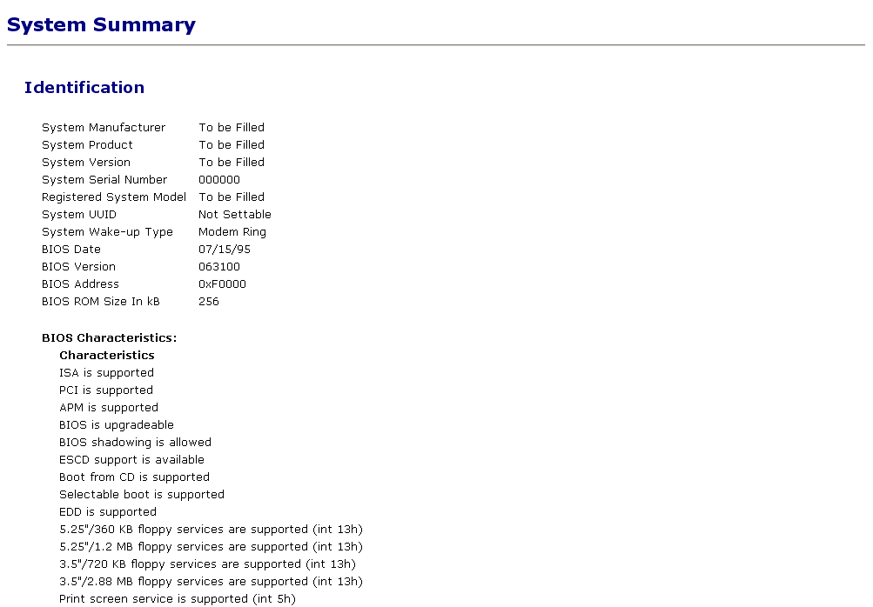
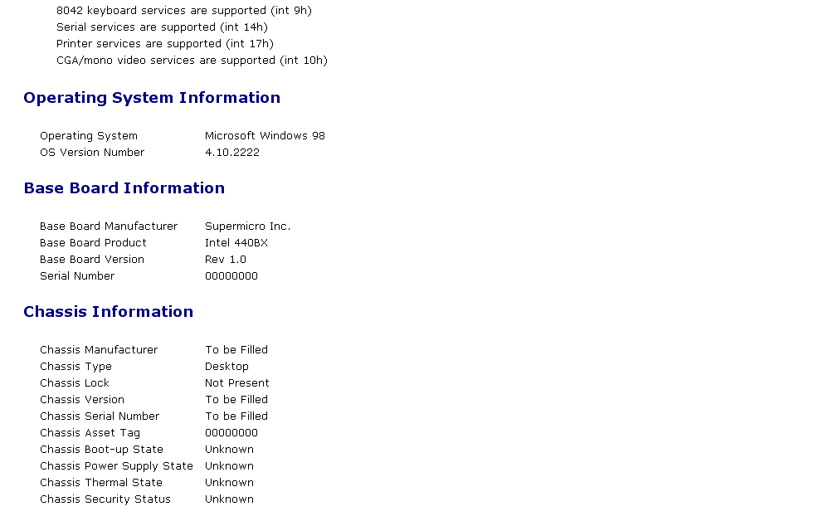

Appendix B – ASI Dashboard Default Configuration

Default ASI Dashboard configuration
It is important for the ASI Dashboard to have a comprehensive set of items enabled by default with robust default values. In this way, most users will be able to use the dashboard “as is” without making any changes until they have become more familiar with the dashboard, and have a better idea of how their specific requirements can be met by the dashboard.

Please note that the complete set of ASI Dashboard items is much larger than the set of the default items. Every item category (e.g. Maintenance) has sample global items that can be copied and edited. However, most items belonging to each item category are disabled. You can access all items for an item category via configuration wizards.

This document describes the list of global enabled ASI Dashboard items. Note that the owner of these items is the master user for the server.

Dashboard left pane configuration
The ASI Dashboard features two default views:
- Sites: all sites and machines
- Groups: all user-defined groups

Notes

Default items
The complete set of ASI Dashboard default items is much larger than the set of the enabled default items. Every item category (e.g. Maintenance) has a comprehensive set of default items that can be copied and edited. However, most of the default items belonging to each item category are disabled. You can access all default items for an item category via configuration wizards.

All default ASI Dashboard items are global, i.e. can be accessed by all users. However, default items cannot be changed by any users except for HandsFree Networks. Users can use default items as templates for new items. When users perform a configure action on a default item, the ASI Dashboard software automatically creates a copy of the selected item. The user can then change the item (including its name) in any way he/she chooses. Users with global rights can make the copy of the default item they have created to be either local (accessible only by them), or global (accessible by all users).

Users can also define brand-new items, global or local, depending on their rights.
When users perform a configuration action on user-defined global ASI Dashboard items, the ASI Dashboard software automatically creates a copy of the selected global item. The user can then change the item (including its name) in any way he/she chooses. Users with global rights can make the copy of the default item they have created to be either local (accessible only by them), or global (accessible by all users).

Event monitoring and update intervals
At the start of dashboard operation, call it time 0, event monitoring for all items will start at time 0 – the length of the event monitoring interval.
Clicking on the Reset button for a view/item has the effect of re-starting the event monitoring interval from the time when the user clicked on the Reset button. The length of the first event monitoring interval after a user clicks on the Reset button is equal to the amount of time left in the monitoring interval when the user clicked on the Reset button.

Status values
We have adopted the homeland security colors as the ASI Dashboard default status color values (we took them from the colors used by the Department of Homeland Security for the Threat Advisory System).

Value | Name | Color | Red | Green | Blue
1 | OK |  | 0 | 153 | 102
2 | warning |  | 247 | 214 | 0
3 | alert |  | 240 | 57 | 66

In the tables contained in the following sections:
- The column labeled Name contains the name of items in each item category that are enabled by default
- The column labeled Criteria contains the number of events corresponding to the item in the Name column that will cause item status to be at Warning or Alert level. For example, for the item Client not reporting, one Client not reporting event in four hours (i.e. an ASI client not reporting to the ASI server for a period of at least four hours) will cause status to be Warning, one Client not reporting event in 17 hours (i.e. an ASI client note reporting to the ASI server for a period of at least 17 hours) will cause status to be Alert.
- The column labeled Inclusion/Exclusion contains the values for the item in the Name column that are either included or excluded when searching for item events. For example, when searching for Backup Exec service stopped events, the key words in the Inclusion/Exclusion column for the Backup Exec service stopped item will be included in the query (i.e. only events including one or more of the key words in the Inclusion/Exclusion column will be retrieved).
- The column labeled Monitoring Interval contains the default value of the monitoring interval for each item in the default ASI Dashboard configuration

Event monitoring and update intervals
The events underlying ASI Dashboard items, i.e. the events delivering the information for each item, have an update and a monitoring interval.

The event monitoring interval is the amount of time over which an item's event logs are retained, and its status is calculated.

The event update interval is the amount of time between execution of the event queries that retrieve an item's event log. Currently, there is one event update interval for all items. By default it is set to one hour.

The event monitoring interval is a rolling interval. When event data collected when the event queries for an item run at the end of the latest event update interval are added to item event log store, the event logs collected by the oldest event update interval are deleted from the item event store.

Every time item event logs are added to an item event store, the item's status is re-calculated.

Default values
- Event monitoring interval – two days
- Event update interval – one hour

Monitored item groups

Clients
The Clients monitored item group includes all systems. Its item type is handled specially. The time of the latest event and time of the last configuration synchronization are computed for each system, and the latest of those two is retained. It is used to compute a parameter representing the number of seconds since the last time the machine contacted the ASI server. This number is compared with the default warning and alert thresholds for "Client not reporting" reported in the table below.
Name | Criteria | Inclusion / Exclusion | Monitoring Interval
Client not reporting | Warning – at least 1 value 4 hours or more  Alert – at least 1 value 22 hours or more |  | 22 hours

Services
The Services monitored item group consists of all MS Windows services included in the default Services to be monitored Services Restart Scrip (#176) configuration parameter. Event filters consisting of "Monitored service has stopped:" followed by one of the services referenced by the item definition (see below) are used to retrieve events for monitored items in the Services monitored item group.
Name | Criteria | Inclusion/Exclusion | Monitoring Interval
APC PowerChute service stopped | Warning – 1-2 items  Alert – 3 or more items | Include "PowerChuteNetShut", "APCPBEAgent", "APCPBEServer", "UPS" | Two days
Arcserve service stopped | Warning – 1-2 items  Alert – 3 or more items | Include "CASDBEngine", "CASDiscoverySvc", "CASJobEngine", "CASMsgEngine", "CASSvcControlSvr", "CASTapeEngine", "CASUnivDomainSvr", "CATIRPC", "DbaRpcService", "OpenFileAgent", "RemoteDbagent" | Two days
Backup Exec service stopped | Warning – 1-2 items  Alert – 3 or more items | Include "BackupExecRPCService", "BackupExecAgentAccelerator", "BackupExecJobEngine", "BackupExecDLO", "DLOAdminSvcu", "BackupExecDeviceMediaService", "BackupExecAgentBrowser", "BackupExecNamingService", "BackupExecNotificationServer", "BackupExecAlertServer" | Two days
Blackberry service stopped | Warning – 1-2 items  Alert – 3 or more items | Include "BlackBerry Router", "BlackBerry Controller", "BlackBerry Synchronization Service", "BlackBerry Policy Service", "BlackBerry Attachment Service", "BlackBerry Database Consistency Service", "BlackBerry Mobile Data Server BES-SERVER1", "BlackBerry Server BES-SERVER1", "BESAlert" | Two days
Brightmail service stopped | Warning – 1-2 items  Alert – 3 or more items | Include "Brightmail Agent", "Brightmail Conduit", "Brightmail Server", "Brightmail SMTP Harvester", "Brightmail Virus Cleaner" | Two days
Citrix service stopped | Warning – 1-2 items  Alert – 3 or more items | Include "CdfSvc", "Cdm", "CdmService", "Citrix SMA Service", "CitrixLicensing", "Citrix_GTLicensingPro", "cpsvc", "CtxAltStr", "CtxHttp", "CTXLMC", "ctxpidmn", "CtxSbx", "ctxsmcdrv", "IMAService", "MFCom" | Two days
DHCP service stopped | Warning – 1-2 items  Alert – 3 or more items | Include "DHCPServer" | Two days
DNS service stopped | Warning – 1-2 items  Alert – 3 or more items | Include "DNS" | Two days
ETrust service stopped | Warning – 1-2 items  Alert – 3 or more items | Include "InoNmSrv", "InoTask", "InoRT", "InoRPC", "INO_FLTR" | Two days
Executive SW Undelete service stopped | Warning – 1-2 items  Alert – 3 or more items | Include "UndeleteService" | Two days
File Replication Service service stopped | Warning – 1-2 items  Alert – 3 or more items | Include "NtFrs" | Two days
IIS service stopped | Warning – 1-2 items  Alert – 3 or more items | Include "IISADMIN", "LicenseService" | Two days
Include service stopped | Warning – 1-2 items  Alert – 3 or more items | Include "Include DC Services & Mail services" | Two days
Intel service stopped | Warning – 1-2 items  Alert – 3 or more items | Include "Intel File Transfer", "Intel PDS" | Two days
Intersite Messaging service stopped | Warning – 1-2 items  Alert – 3 or more items | Include "IsmServ" | Two days
ISA server service stopped | Warning – 1-2 items  Alert – 3 or more items | Include "isactrl", "MspFltEx", "MspNAT" | Two days
Kerberos Key Distribution Center service stopped | Warning – 1-2 items  Alert – 3 or more items | Include "kdc" | Two days
McAfee services service stopped | Warning – 1-2 items  Alert – 3 or more items | Include "AVExch32Service", "AVUPDService", "McAfee GroupShield", "McAfeeFramework", "McShield", "McTaskManager", "Network Associates Log Service", "Outbreak Manager" | Two days
Microsoft Search service stopped | Warning – 1-2 items  Alert – 3 or more items | Include "MSSEARCH" | Two days
MS Exchange service stopped | Warning – 1-2 items  Alert – 3 or more items | Include "MSExchangeIS", "MSExchangeSA", "MSExchangeMTA", "RESvc", "MSExchangeMGMT", "MSExchangeDS", "MSExchangeMT", "MSExchangeES", "IMAP4Svc", "POP3Svc", "MSExchangeSRS" | Two days
MS message queueing service stopped | Warning – 1-2 items  Alert – 3 or more items | Include "MSMQ" | Two days
MS SQL Server service stopped | Warning – 1-2 items  Alert – 3 or more items | Include "SQLSERVERAGENT", "MSSQLSERVER", "MSSQL$BKUPEXEC", "MSSQLServerADHelper", "MSDTC", "MSSQL$MWP", "MSSQL$SHAREPOINT", "MSSQL$SBSMONITORING", "SQLAgent$SBSMONITORING", "MSSQL$VAULT_LOGIX", "MSSQLServerOLAPService" | Two days
Print Spooler service stopped | Warning – 1-2 items  Alert – 3 or more items | Include "Spooler" | Two days
RPC service stopped | Warning – 1-2 items  Alert – 3 or more items | Include "RpcSs", "RpcLocator" | Two days
SBS service stopped | Warning – 1-2 items  Alert – 3 or more items | Include "SBCore", "MSPOP3Connector" | Two days
SMTP service stopped | Warning – 1-2 items  Alert – 3 or more items | Include "SMTPSVC" | Two days
Symantec service stopped | Warning – 1-2 items  Alert – 3 or more items | Include "SAVSMTP", "Norton AntiVirus Server", "DefWatch", "NSCTOP", "SAVFMSE", "ccEvtMgr", "ccSetMgr", "SMSMSE", "Symantec AntiVirus", "SavRoam", "NAVAPEL", "SAVRTPEL", "SMSSMTP" | Two days
Terminal Services service stopped | Warning – 1-2 items  Alert – 3 or more items | Include "TermService", "Tssdis", "TermServLicensing", "TermDD" | Two days
Trend Micro service stopped | Warning – 1-2 items  Alert – 3 or more items | Include "ntrtscan", "ofcservice", "TmFilter", "tmlisten", "TmPreFilter", "VSApiNt" | Two days

Profile items
The default asset profile displayed for each system in the ASI Dashboard contains the following asset items:
- System Product
- Operating System
- NT Installed Service Pack
- NT Product Type
- Processor Family
- Processor Current Speed in MHz
- Processor CurSpeed in Megahertz
- Site Name
- User Name
- Physical Memory Total (Kbytes)
- IP address
- Logical Disk Name
- Logical Disk KBytes total
- Logical Disk KBytes used
- Logical Disk Percentage free
- ASI UUID

Security items
Name | Criteria | Inclusion/Exclusion | Monitoring Interval
Intrusion protection startup item rejected | Warning – 50 or more items  Alert -- 100 or more items | Scrip 27 exclusion list (see below) | Two days
Intrusion protection config item rejected | Warning – 50 or more items  Alert -- 100 or more items | Scrip 232 exclusion list (see below) | Two days
Anti-virus is not installed | Alert – 0 items  OK – >0 items |  | Two days
Anti-virus definition update failed to run | Warning – 1 or more items  Alert -- 3 or more items |  | Two days
Anti-virus definition update ran but failed | Warning – 1 or more items  Alert -- 3 or more items |  | Two days
Anti-virus definition update succeeded | always OK |  | Two days
Anti-virus scan failed to run | Warning – 1 or more items  Alert -- 3 or more items |  | Two days
Anti-virus scan ran but failed | Warning – 1 or more items  Alert -- 3 or more items |  | Two days
Anti-virus scan succeeded | always OK |  | Two days
Anti-virus definitions are out of date with others on the site | Warning – 7 days or more  Alert – 14 days or more |  | Two days
Anti-virus definitions are out of date | Warning – 7 days or more  Alert – 14 days or more |  | Two days
Intrusion management item enabled/disabled | Warning – 5 or more changes  Alert – 10 or more changes |  | Two days

Intrusion protection exclusion lists
The goal of the intrusion protection items used to report rejection/disabling of attempts to add items to a system's areas protected by Scrips 27 (System Start-up Control) and 232 (Intrusion Protection Control) is to alert users about potential malware infiltration attempts.

The exclusion lists you will find below, include all key words used to exclude Scrip 27 and 232 rejection/disabling of items that are legitimate, and Scrip 27 and 232 actions not related to specific malware rejection/disabling. Please note that rejection/disabling of legitimate items can be minimized by including such items in the Permitted items configuration parameter in Scrips 27 and 232.

Scrip 27 (System Start-up Control) exclusion list
- Failed to obtain the startup folder
- Failed to obtain the system startup folder
- alist
- corrupt
- Bad reg string value
- Could not find item
- operation
- Background Intelligent Transfer Service
- because it was initiated by this application
- NVSvc
- WmdmPmSp
- Wmdm PmSp
- uploadmgr
- spupdsvc
- error occurred attempting to reject the change
- security center
- afd networking
- dcom server
- svchost.exe
- ibm access
- kernelfaultcheck
- indexing service
- navapel
- norton antivirus server
- savrtpel
- ctfmon
- mobsync
- rpcpatch
- dcomlaunch
- wscsvc
- ibmmessages.exe
- hotsync manager
- desktop.ini
- office startup
- millennium agent
- powerreg scheduler
- Webshots
- reminder-ScanSoft
- powerword
- adcscm
- cold fusion
- protected storage
- Microsoft Office.lnk
- symtdi.sys
- tcpip.sys
- netbt
- lmhosts
- policyagent
- adobedownloadmanager.exe
- acrotray.exe
- cisco systems vpn client
- atiptaxx
- directcd.exe
- ccapp.exe
- Ad-Watch.exe
- ati2evxx.exe
- easyshare.exe
- kodak software update.exe
- aol.exe
- aom.lnk
- navex15
- savrt
- AdobeUpdateManager.exe
- SAVScan.exe
- egathdrv
- GoogleDCClient
- Connected TaskBar Icon
- ntdd.sys
- msiexec.exe
- cleanup
- userfaultcheck
- ikernel.exe
- basfnd
- wanmpsvc
- atwpkt2
- smtray.exe
- kernelfaultcheck
- avsynmgr
- sndsrvc.exe
- naveng.sys
- mcupdmgr.exe
- mcappins.exe
- adobelmsvc
- googledesktopsearch
- aol fast start
- aol acs
- quicken
- symantec antivirus
- ccsetmgr
- ccevtmgr
- savroam
- naveng
- ituneshelper.exe
- aolhostmanager
- aolacsd.exe
- aolond~1.exe
- versioncuetray.exe
- adobe gamma loader.exe
- qctray.exe
- qcwlicon.exe
- diskeeper
- spybotsnd
- qconsvc
- cvpnd
- dxdllreg.exe
- umwdf
- wdfmgr.exe
- mm_tray.exe
- msgcenter.exe
- navap
- defwatch
- symevent.sys
- rtvscan.exe
- idriver.exe
- eraserutildrv
- mssql$arrayassist
- symantec eraser control
- idrivert.exe
- realonemessagecenter
- msgcenterexef
- yahoomessenger.exe
- msnappau.exe
- aim.exe
- ypager.exe
- msnmsgr.exe
- msmsgs.exe
- aolond~1.exe
- yahoomessenger.exe
- realsched.exe
- ituneshelper
- quicktime task
- tkbellexe
- digstream
- ituneshelper.exe
- mm_tray.exe
- msgcenter.exe
- realonemessagecenter
- msgcenterexe
- disk driver
- usb mass storage driver
- system restore filter driver
- adobeupdatemanager
- clpciid
- Microsoft NetMeeting
- IMEKRMIG.EXE
- change was accepted automatically
- CreateCD.exe
- SpySweeper.exe
- ADUserMon.exe
- apdproxy.exe
- WCESCOMM.EXE
- googletalk.exe
- permitted items
- internat.exe
- spuninst.exe
- netfxupdate.exe
- quicktimeupdatehelper.exe
- quicktimeinstaller.exe
- qtplugininstaller.exe
- adobeupdater.exe
- onetouch.exe
- ucstartup.exe
- sgtray.exe
- IBM fingerprint software
- tfswctrl.exe
- hkcmd.exe
- igfxtray.exe
- PWRMGRTR.DLL
- SynTPEnh.exe
- SynTPLpr.exe
- EarthLink TotalAccess
- WMPNSCFG

Scrip 232 (Intrusion Protection Control) exclusion list
- because it was initiated by this application
- Yahoo!
- googletoolbar
- MSN apps
- webshots
- Windows Media Player
- msn toolbar
- shdocvw.dll
- PropertySheetHandlers
- DragDropHandlers
- ContextMenuHandlers
- NavLogon -> LoginDomain
- Notify -> igfxcui
- notify -> LoginDomain
- notify -> NavLogon
- AcroIEHlprObj Class
- wgalogon
- start page
- search page
- screen saver
- SCRNSAVE.EXE
- searchassistant
- CustomizeSearch
- NavLogon -> LoginDomain
- ContextMenuHandlers
- 5CA3D70E-1895-11CF-8E15-001234567890
- 08B0E5C0-4FCB-11CF-AAA5-00401C608501
- 2EAF5BB1-070F-11D3-9307-00C04FAE2D4F
- Toolbar Extension for Executable

Resource items
In the right pane display for resource items, Values in the "Item Count" column are equal to the number of events that meet or exceed the threshold set by the criterion of each item listed in the table below.
For example, consider the "CPU utilization" resource monitoring item. Its default configuration settings are:
Warning - 20 event logs per hour reporting 75% or higher CPU utilization
Alert - 30 event logs per hour reporting 90% or higher CPU utilization
Monitoring interval - four hours
CPU utilization is at warning level if during the current monitoring interval at least 80 (20 x 4) processor statistics event logs are produced.
CPU utilization is at alert level if during the current monitoring interval at least 120 (30 x 4) processor statistics event logs are produced.
Suppose the status for the "CPU utilization" item for a system is warning and the item count is 132 (132 > 80). This means that during the past four hours there have been 132 event logs reporting CPU utilization at 75% or higher. When you click on the "detail" link for this "CPU utilization" item, a total of 166 processor statistics event logs are listed. of these, 108 report CPU utilization between 75 and 89, and 24 report CPU utilization between 90 and 100 (24 < 120). The rest of the processor statistics event log were generated because other CPU related thresholds were exceeded.
Name | Criteria | Monitoring Interval
CPU utilization | Warning - at least 80 values 75% or more  Alert - at least 120 values 90% or more | Four hours
CPU interrupt rate | Warning - at least 80 values 3000 or more  Alert - at least 120 values 5000 or more | Four hours
CPU queue length | Warning - at least 80 values 10 or more  Alert - at least 120 values 18 or more | Four hours
Physical memory percent free | Alert - at least 30 values 0% | One hour
Virtual memory percent free | Alert - at least 30 values 2% or less | One hour
Swap space percent free | Alert - at least 30 values 2% or less | One hour
Page read rate | Warning - at least 20 values 300 or more  Alert - at least 30 values 500 or more | One hour
Disk space free percent | value 10% or less warning, value 5% or less alert | Four hours
Network utilization | Warning - at least 80 values 50% or more  Alert - at least 120 values 75% or more | Four hours
Network transmit bandwidth | Warning - at least 80 values 50000 or more  Alert - at least 120 values 100000 or more | Four hours
Network receive bandwidth | Warning - at least 80 values 50000 or more  Alert - at least 120 values 100000 or more | Four hours

Event items
MS Windows Error Event Logs Events of Interest
Name | Criteria | Monitoring Interval
Windows event log change detected | Warning – 50  Alert – 100 | Two Days

Mass Storage Related Events of Interest
Name | Criteria | Monitoring Interval
disk array status change | Warning – <=2  Alert – >=3 | Two days
disk controller error | Warning – <=2  Alert – >=3 | Two days
disk did not respond | Warning – <=2  Alert – >=3 | Two days
mass storage device has bad block | Warning – <=2  Alert – >=3 | Two days
Compaq physical drive failure | Warning – <=2  Alert – >=3 | Two days
disk - ft set cannot be used | Warning – <=2  Alert – >=3 | Two days
disk - port timeout due to prolonged inactivity | Warning – <=2  Alert – >=3 | Two days
disk - not ready for access | Warning – <=2  Alert – >=3 | Two days
disk - driver detected a controller error | Warning – <=2  Alert – >=3 | Two days
disk - parity error | Warning – <=2  Alert – >=3 | Two days
disk - ftdisk failed | Warning – <=2  Alert – >=3 | Two days
mass storage device has bad block - disk | Warning – <=2  Alert – >=3 | Two days

General Events of Interest
Name | Criteria | Monitoring Interval
Resource issues | Warning – 10  Alert – 50 | Two days
Printing issues - filtered | Warning – 10  Alert – 50 | Two days
Unexpected application errors | Warning – 10  Alert – 50 | Two days
unexpected system shutdown | Alert – =1 | Two days

MS Outlook Events of Interest
Name
add-in could not be installed
Outlook error - cannot start outlook
Outlook errors - error procssng requested tasks
Outlook errors - exchange server not available
Outlook errors - exchange svr net problems
Outlook error - is in use and could not be accsd
Outlook errors - inbox folder coud not be found
Outlook error - info store could not be opened
Outlook errors - item could not be moved
Outlook errors - msg interf returned unknown err
Outlook errors - name could not be resolved
outlook errors - unable to open dflt e-mail folder
outlook errors - your ms exchnge svr is unavailabl
Outlook errors - failed to start correctly
Outlook errors - no permission to log on
Outlook errors - server not available
Outlook errors - stationery not installed yet
Outlook errors - ms wordmail could not be started

For all of the above:
- Warning – 50
- Alert – 250
- Monitoring interval – Two days

This means that the above thresholds apply to the total number of events retrieved using all of the above filters.

Connectivity Related Events of Interest
Name
conn - access denied filters
Conn - authentication failed
conn - cannot bind socket for incoming request
conn - cannot connect to printer
conn - cannot connect to the Citrix server
conn - computer or share name could not be found
conn - connection has not been restored
conn - device not available filters
conn - error while trying to connect to network
conn - error in connection
conn - error on the network
Conn - error occurred while reconnecting
conn - error writing to printer
conn - connection with firewall timed-out
conn - Limited or no connectivity
Conn - local device name already in use
conn - location unavailable
conn - there may be problem with net connection
conn - network access denied
conn - network connection may have been lost
Conn - net connection could not be found
conn - network error has occurred
conn - network location cannot be reached
conn - network name cannot be found
conn - specified net name is no longer available
conn - network path was not found
conn - net resource or device no longer avail
conn - system couldnt log you into network
conn - no domain server available
conn - not accessible
conn - client could not connect to remote comptr
conn - client could not connect to terminal server
conn - path cannot be found
conn - permanent connection not available
conn - specified remote comptr couldnt be found
conn - remote general
Conn - timed out waiting for authenticn
Conn - timed out waiting for vpn server
conn - unable to browse network
conn - unable to connect to host
conn - unable to connect
conn - unable to establish vpn connection
conn - windows cannot connect to the printer
conn - windows cant find computer or share name
Conn - wireless connection repair

For all of the above:
- Warning – 100
- Alert – 500
- Monitoring interval – two days

This means that the above thresholds apply to the total number of events retrieved using all of the above filters.

Maintenance items
Name | Criteria | Monitoring Interval
Defrag failed | Warning – 1 or more items  Alert - 4 or more items | Two days
Defrag succeeded | Alert – 0 items  OK – >0 items | Two days
File cleanup | always OK | Two days
Clock sync ran but failed | Warning – 1 or more items  Alert - 4 or more items | Two days
Clock sync succeeded | Alert – 0 items  OK – >0 items | Two days
System clock has drifted | Warning – 1 or more items  Alert - 4 or more items | Two days

